**Textile Design Application Scope**

**Total Screens:** Seven (Flexible)

**Technology:** Full Stack Development tools

**Development Space:** Website with mobile responsive

**Database:** MySQL or No SQL

**Integration:** The developed screens should be integrated with website.

**Sample Screen** *(The screen layouts will change based on the product type, predefined mouse actions should take place based on the type of the product)*

**Virtual Fitting Room**

Display the Self Mannequin with the designed dress

**Design Tools**

Gender

Product Type

Product Category

Product Sub Category

Product Model

Fabric

Thread count (for handmade products only)

Color

Design Category

Design Type

Design Model

**Design Body**

**Fashion Parade**

Display the Self Mannequin with the dress in different pre-defined poses.

References: <https://www.sumissura.com/en-us/women/women-suits/personalize/?step=config>

<https://tri3d.in/garment-visualization-software/online-saree-draping-software/>

<https://browzwear.com/>

1. Product Types: Sarees, Blouses, Chudidhars, Shirts & Trousers for both men and women, Jackets
2. Product Sub Category: Tupe of product *(Example for Chudidhars (Straight Churidar, Anarkali Churidar, Patiala Churidar, Palazzo Churidar, Dhoti-style Churidar, Sharara Churidar, Cigarette Pants Churidar etc.)*
3. Product Model: Product pictures with outlines will be uploaded in our content management module, the users will be able to drag, shrink, adjust these outlines in the design body.

*Example:*

* *Product Types: Saree*
* *Product Sub Category: Saree body, pallu, end knots, blouse material for stitching, Fall*

Each product type will have it’s own parameters like, when the customer selects Shirt as a product type then all the parameters required for the shirt should display like Collar type, Pocket, Cuffs, Buttons, Stich Type, Button Strip Type etc. All these items will be stored in Admin – Content management section.

For every control data, we need to provide short & long description

Audit fields to be added for all control data (Entered By, Datetime, Modified By, Datetime, Approved By, datetime)

Effective date and effective status to be added to all control data elements

This require database with admin panel to allow customers and their users to use the tool with seamless sign-in authentication.

Admin panel- content management, Inventory module to create a BoQ, pricing module, discounts and deals, stored designs, transaction history etc.

**Example: Product Type – Saree.**

1. The design palette should contain the following ‘**SECTIONS**’.
2. Top border,
3. Bottom Border,
4. Pallu,
5. Saree Body
6. End-knots
7. Blouse
8. Fall
9. The user should be able to define and assign the dimensions to each of this section using mouse.
10. User should be able to select either full section or a predefined area using the mouse and then select the art works by art category those are displayed in design pallet for each of the above sections or draw his/her own drawing on that section.
11. The user should be able to magnify any of the individual sections mentioned above.
12. Add/Edit/Modify/Delete options to be provided in the design pallet for the complete designs or any new designs created by the user.
13. The design should have the auto save option and the design should save in our cloud at a predefined frequency defined in our Admin Panel.
14. User should be able to create multiple designs and add them to their wish list (Called as My Designs in Design Pallet)
15. **Custom Design:** Our portal will maintain predefined designs for complete sarees, borders, Pallu, blouse etc which will be displayed in our portal. User should be able to select our predefined designs stored in our Stores and select them to modify any of the sections in our design pallet. As soon as the user selects an existing design, the design should populate in custom saree design tab.
16. **Create Design:** User can use the design pallet to create her own designs in any of the sections from the scratch.
17. Admin portal should be able to define designs, clip arts, images, art categories, art works, end-knots models, colors, yarns, zaree, fall materials, embroidery materials and accessories that are required for blouses and end-knots. Admin portal will facilitate uploading these art categories, art works, colors, yarns, zaree, embroidery materials and accessories for end-knots, so that user can view them in design pallet. The user should be able to view these items/materials in design pallet with a magnifying option before or after selection.
18. Design palette should have some basic tools for user to draw, erase, fill the color, selection of Color and spread the design evenly from right click of the mouse.
19. User should be able to select only the items that are stored in our database for their designs.
20. User should be able select the yarn type, thread count, zaree type, zaree count, colors for each section and art works, embroidery materials for embroidery designs on saree and blouse.
21. The blouse section should display the predefined areas in design pallet from the measurements table uploaded by the user’s 3D self-mannequin. User should be able to apply the designs to the blouse section.
22. User should be able to test the look and feel of those designs on their uploaded mannequin at any time while designing and after the design is complete. The mannequin should display individual sections (Full Saree, Blouse, borders, Pallu, End-knots and Fall) separately and the whole body After the design is completed, user should be able preview on mannequin(Refer mannequin requirement) by taking Self picture.
23. To dynamically determine the price, the design palette should acquire the material rates from the inventory module, in addition to the margins specified in the admin panel.
24. User should be able to share any section, artwork, designs, individual mannequin in social platforms like Whatsapp, Instagram, Facebook, Pinterest etc.
25. Design pallet will be able to provide the output in .bmp/jpeg/svg formats.

Existing Sample Design Pallet design, however you are free to provide any other user friendly template as accepted by the client:

Sample Blouse Designs: https://youtu.be/calAmuKruJE

**Integration to the websites:**

1. Any Tech that can be preferred but the tech should be able to compatible to the below logic.
2. There will be database in the design palette it will interact with the API.
3. **Calling *Design Palette API*:**
4. The design palette will be opened in the separate tab of the browser, whenever the user clicks on the design in the ***site***, the ***site*** will open the separate tab using the *design palette API* by passing the compatible file location in encrypted format and the cipher.
5. Using the cipher, the design palette must authenticate the user with server, then provide the option to the user to modify/view the design.
6. For the new design also, the process is same, and the ***site*** will create an empty design file and pass that compatible file location in encrypted format along with the cipher.
7. Calling ***site API***from Design Palette:
   * 1. When the user finishes the design and click on save, the design palette should call the site API by passing the completed design file and cipher.
     2. Design palette should call the API very frequently to auto save the file and the timing can be discussed.

Sample Screen Designs (Developer is free to design the pages as suits the project)

**Sample Saree Page/Tab**

**Saree Body Mouse Actions:**

1. Select Saree Type *(Right click on the Template - This will show the type of sarees we were able to manufacture in our database)*
2. *Select Thread Type (This will show the allowed thread types for that particular Saree Type in our database)*
3. *Select Zarie Type (This will show the allowed zarie types for that particular Saree Type in our database)*
4. Select Thread Count *(Right click on the Template - This will show the allowed thread count for that particular Saree Type in our database)*
5. Select Area for Top Border*(There will be a predefined allowed area that can be resized using mouse)*
6. Select Area for Bottom Border *(There will be a predefined allowed area that can be resized using mouse)*
7. Select Area for Top Border *(There will be a predefined allowed area that can be resized using mouse)*
8. Select Area for Pallu *(There will be a predefined allowed area that can be resized using mouse)*
9. Select Area for Saree Body *(There will be a predefined allowed area that can be resized using mouse)*
10. Select Area for Blouse *(There will be a predefined allowed area that can be resized using mouse)*
11. Select Area for Fall *(There will be a predefined allowed area that can be resized using mouse)*
12. Select Area for Design *(Select the area on any space on any section for adding designs , we should be able to resize with mouse. Once the area is selected we should be able to drag and drop the selected artwork/designs )*
13. Select Color *(Select the area on any section or part of the section and change the color (from our data base), change the color of the complete artwork or part of the artwork or design that were placed on the selected area individually or evenly)*
14. Spread the Design *- This is a sub selection of Select Area Design Option – (the design selected shall be spread across the selected area)*
15. Move the design- *(drag and drop the design from the selected area to any section)*
16. Resize Art work – *(With mouse we should be able to minimize or enlarge without loosing it’s pixel strength)*
17. Resize the Design - *(With mouse we should be able to minimize or enlarge without loosing it’s pixel strength)*

**Blouse Page/Tab**

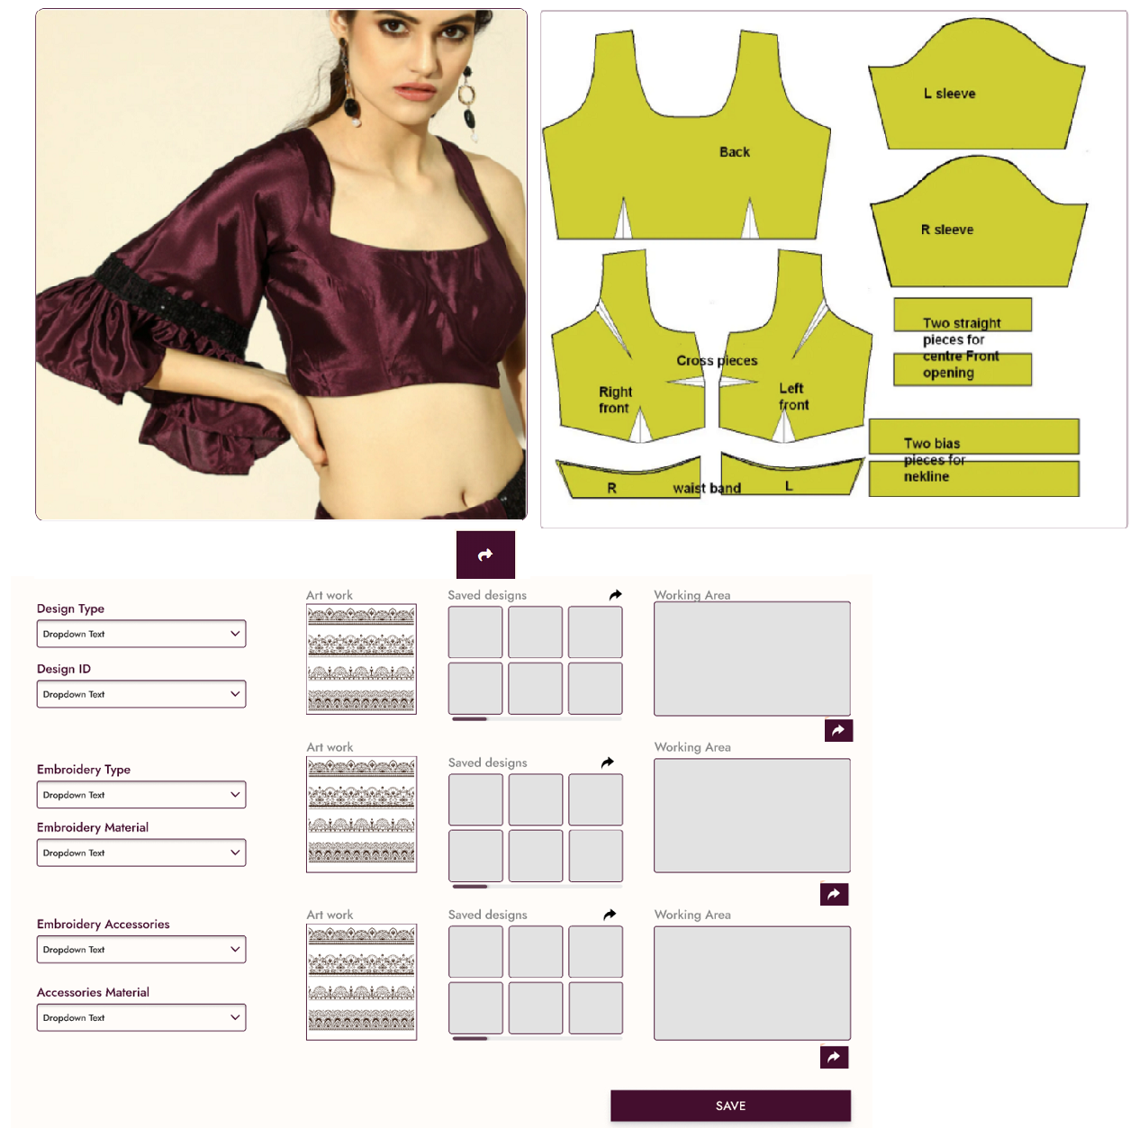

All these sizes will change automatically based on the measurement table given in Mannequin Table based on the Blouse Type. Border sizes can be defined by mouse select area feature.

Preview will show the blouse on self Mannequin bust size with the blouse

Preview

**Blouse Mouse Action Items:**

* *Select Thread Type (This will show the allowed thread types for that particular Saree Type in our database)*
* *Select Zarie Type (This will show the allowed zarie types for that particular Saree Type in our database)*
* Select Thread Count *(Right click on the Template - This will show the allowed thread count for that particular Saree Type in our database)*
* Blouse Type *(Right click on the mannequin display box - This will show the type of blouses we have in our database)*
* Front Neck Type *(The selected neck type should display exactly at the center of the blouse, Show the list of closure types we have on a page)*
* Hand Type *(Show the list of hand types we have in our database on a page)*
* Change Hand Type & Size *(should be able to adjust length, width, drag to a curve or change the color. The modified sizes should be equal for both right and left hand, however the user can change different colors for left & right hand)*
* Front Neck Size *(With mouse we can drag up, down, wide etc)*
* Front Closure Type *(Show the list of closure types we have on a page)*
* Front Closure Buttons *(Show the list of button types we have on a page)*
* Breast shape *(Show the list of breast types we have on a page)*
* Back Neck Type *(This should display exactly at the center of the blouse )*
* Back Neck Size *(With mouse we can drag up, down, wide etc)*
* Back Closure Type *(Show the list of closure types we have on a page)*
* Back Closure Buttons *(Show the list of button types we have on a page)*
* Select Area for Design *(Select the area on any space on blouse area for adding designs , we should be able to resize with mouse. Once the area is selected we should be able to drag and drop the selected bottom design type, embroidery type and embroidery materials. )*
* Select Color *(Select the area on any space on blouse area and change the color (from our data base), change the color of the designs that were placed on the selected area individually or evenly)*
* Spread the Design *- This is a sub selection of Select Area Design Option – (the design selected shall be spread across the selected area)*

**Mannequin Page/Tab –** This is an external API, we should be able to modify the measurements in a new column.

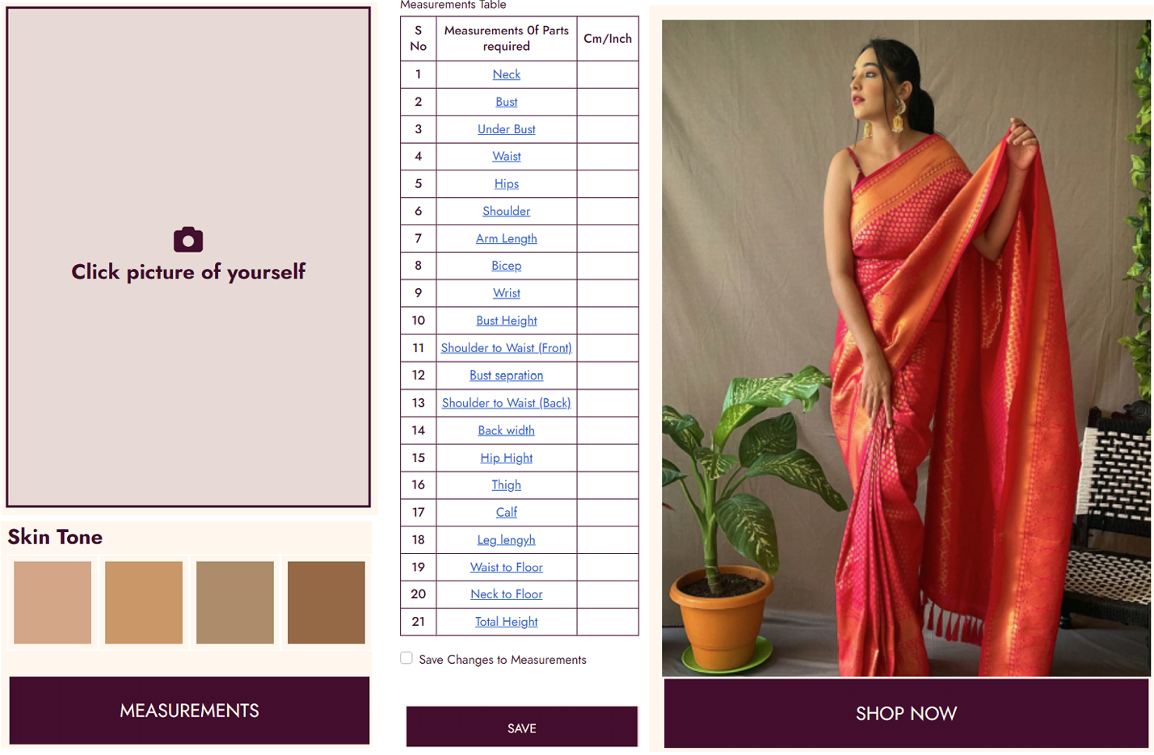

There will be a plug-in from 3rd party software to populate this table, user can update the prepopulated measurements at any time.

**Preview**

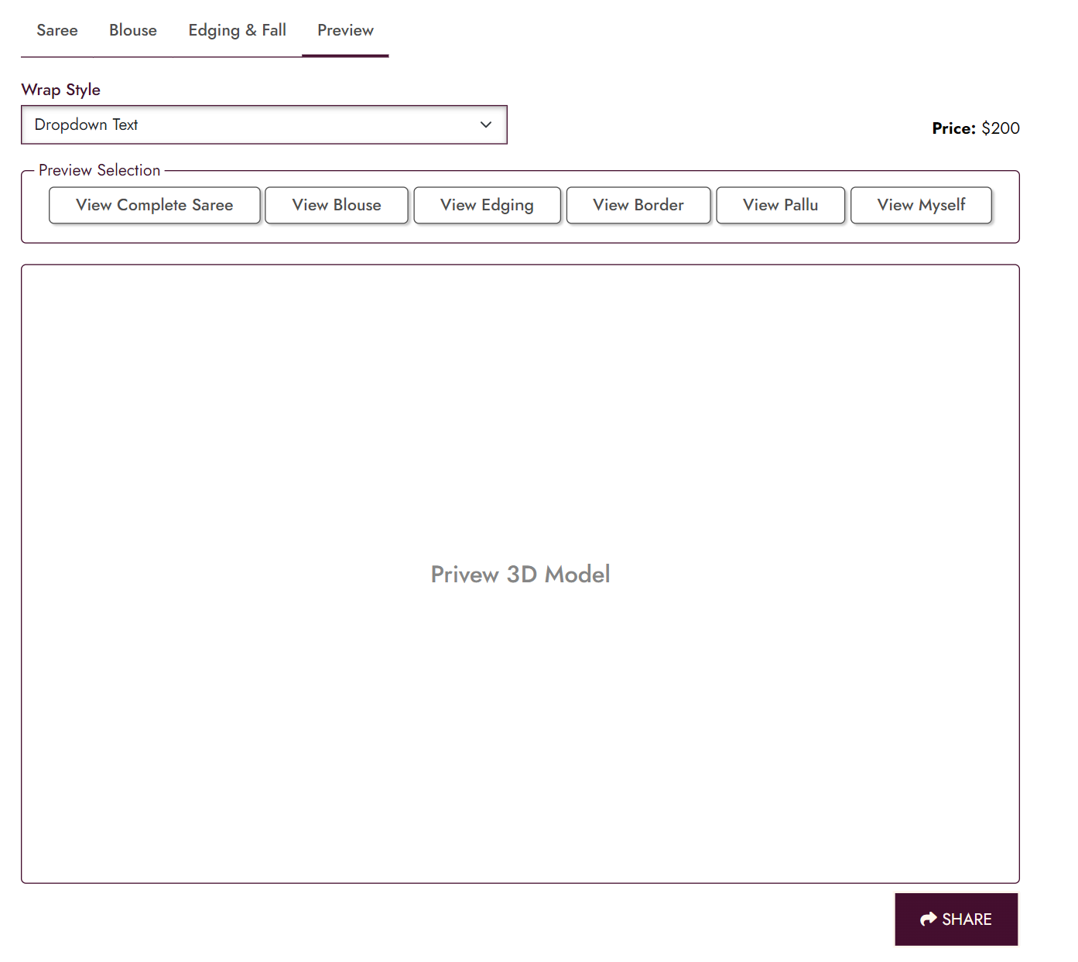

Some of the actions will go to mouse right click

**Edging & Fall Mouse Actions:**

1. Select edge type
2. *Select Thread Type*
3. Select Thread Count
4. Select thread color
5. Select Area for edging
6. Select fall type
7. *Select Fabric type*
8. *Select color*
9. *Select sewing thread type*
10. *Select sewing thread color*
11. Select Area fall area.